影像處理作業-HW4

學生：林正浩 學號：r11631029 日期：11/15

1. 介面介紹：

製作了三個tab去執行。

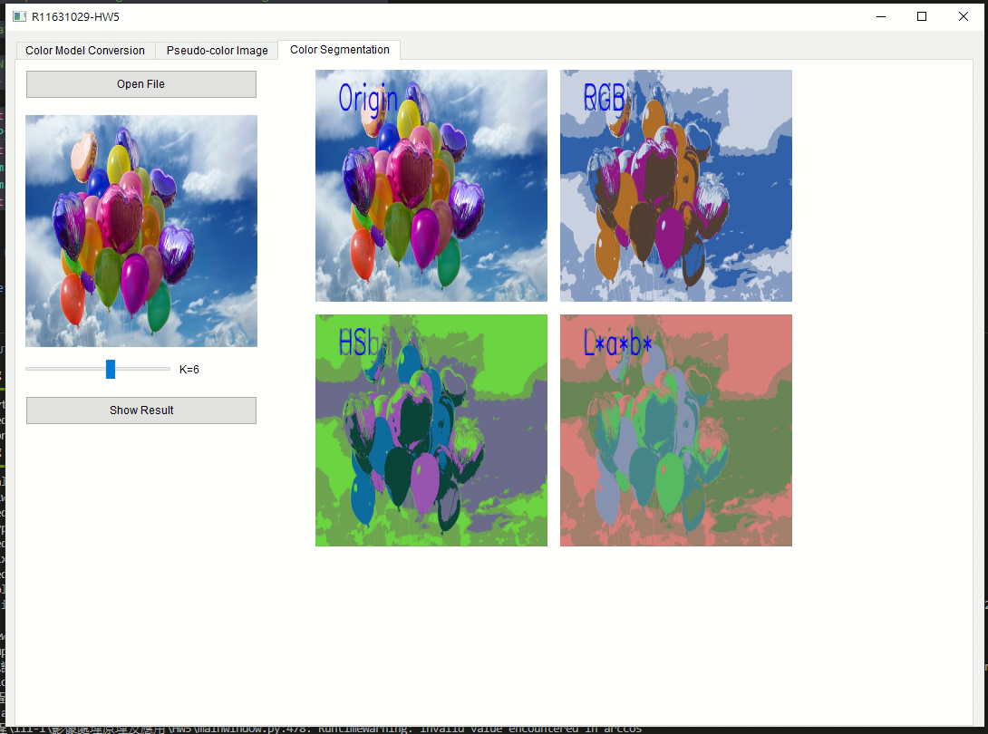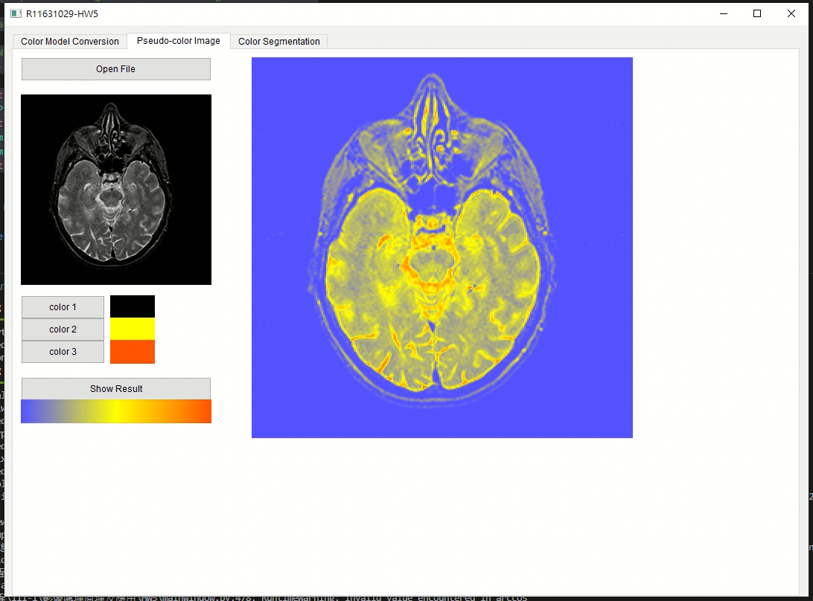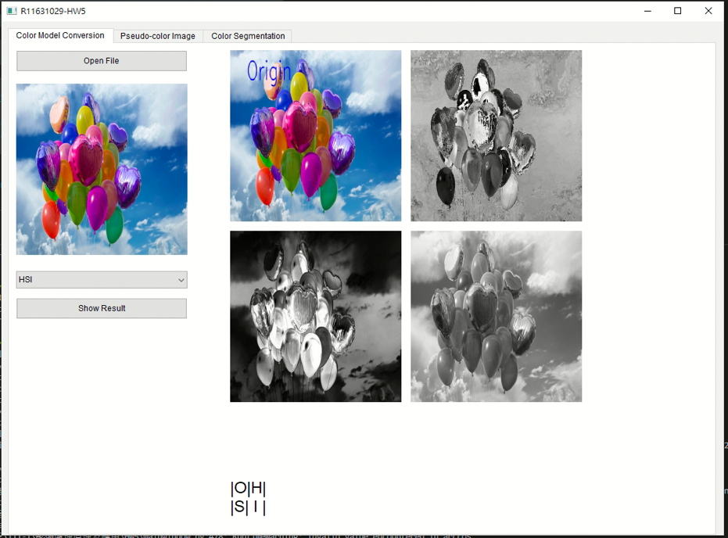

1. Color Model Conversion

透過課本及網路的演算法進行圖片的演算，因為圖片眾多就擺上幾張成果。

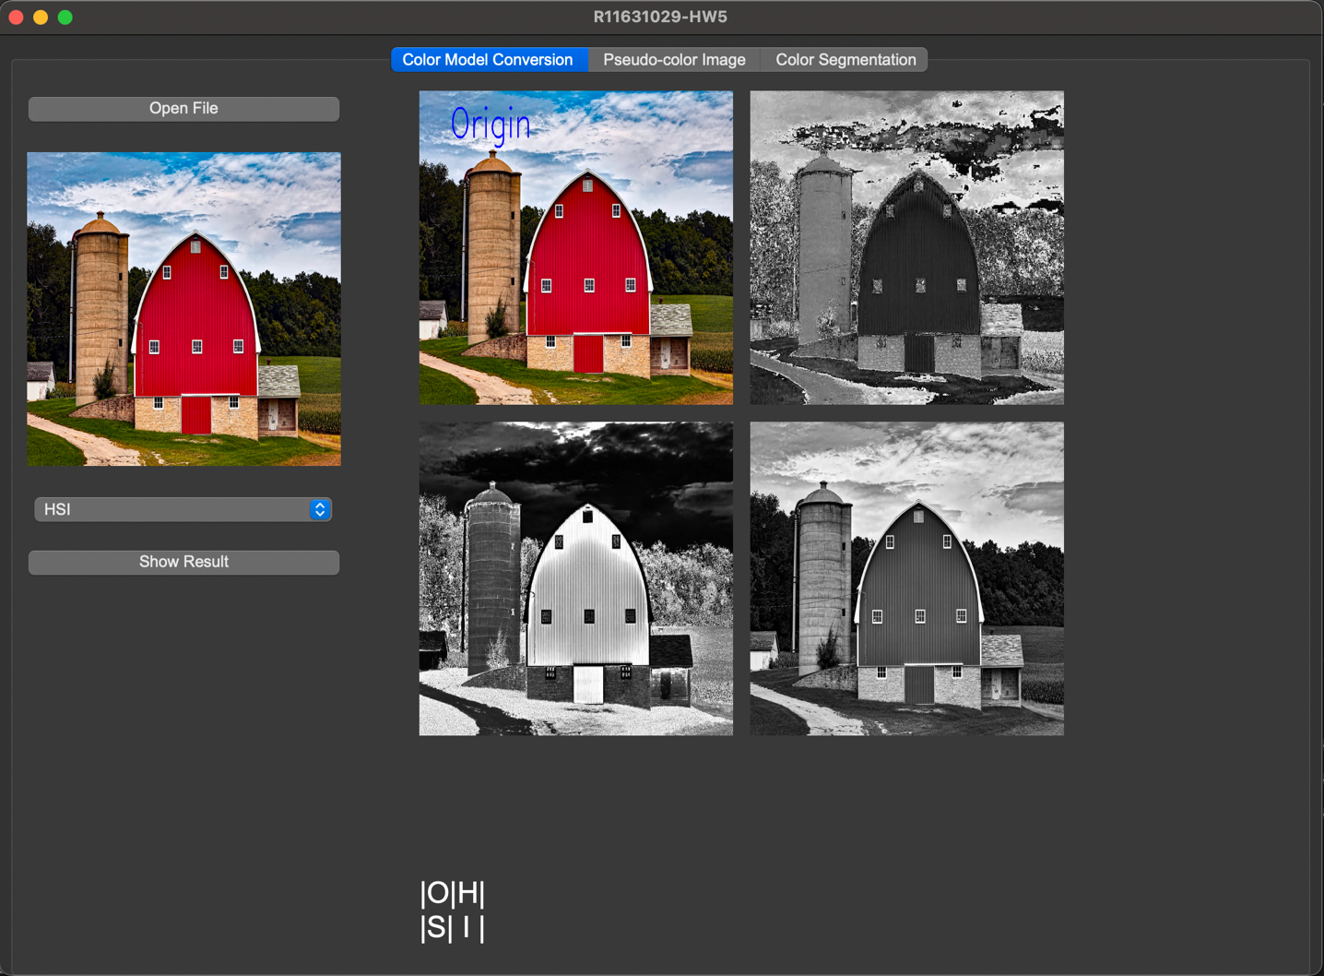

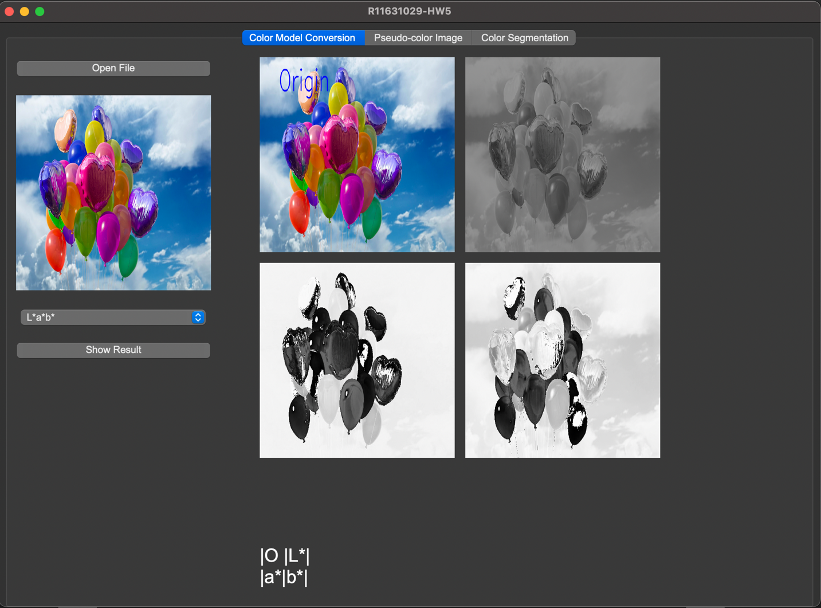

1. Pseudo-color Image

程式上我是透過自定義三個顏色的colormap去進行演算。

Code:

def fake_color(gray, colorarray):

# colorarray = [[1, 0, 0 ,1 ], [0, 0.4116, 0.27107143 ,1 ], [.57647055, 0, 0.27107143 ,1 ]]

Cmap = LinearSegmentedColormap.from_list('myCmap', colors = colorarray, N = 256)

# get cmap array

cmap = plt.cm.get_cmap(Cmap)

colors = cmap(np.arange(cmap.N))

# creat image for colormap

color_img = np.ones((32, 256, 3))

for k in range(3):

for i in range(32):

for j in range(256):

color_img[i , j, k] = colors[j][k] * 255

color_img = cv2.cvtColor(color_img.astype('uint8'), cv2.COLOR_RGB2BGR)

R = np.ones(gray.shape)

G = np.ones(gray.shape)

B = np.ones(gray.shape)

h, w =gray.shape

for i in range(h):

for j in range(w):

R[i, j] = colors[gray[i, j]][0]

G[i, j] = colors[gray[i, j]][1]

B[i, j] = colors[gray[i, j]][2]

BGR = cv2.merge((B, G, R)) * 255

return BGR, color_img

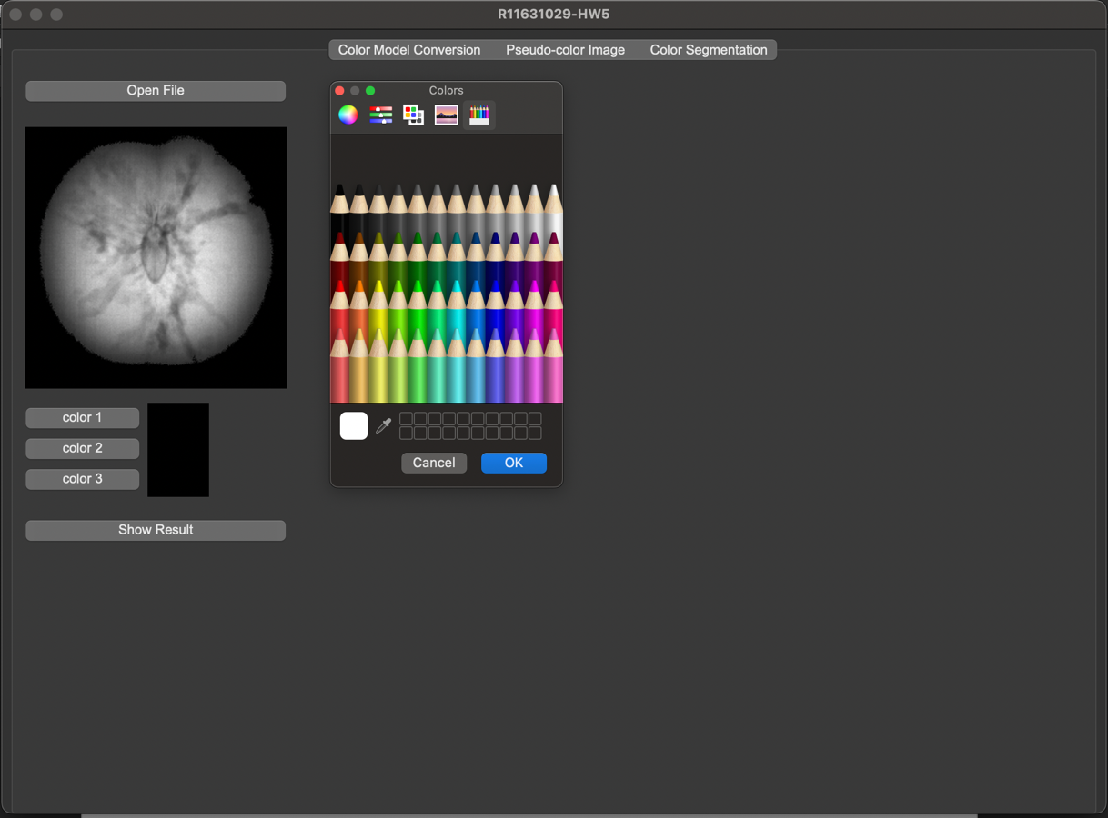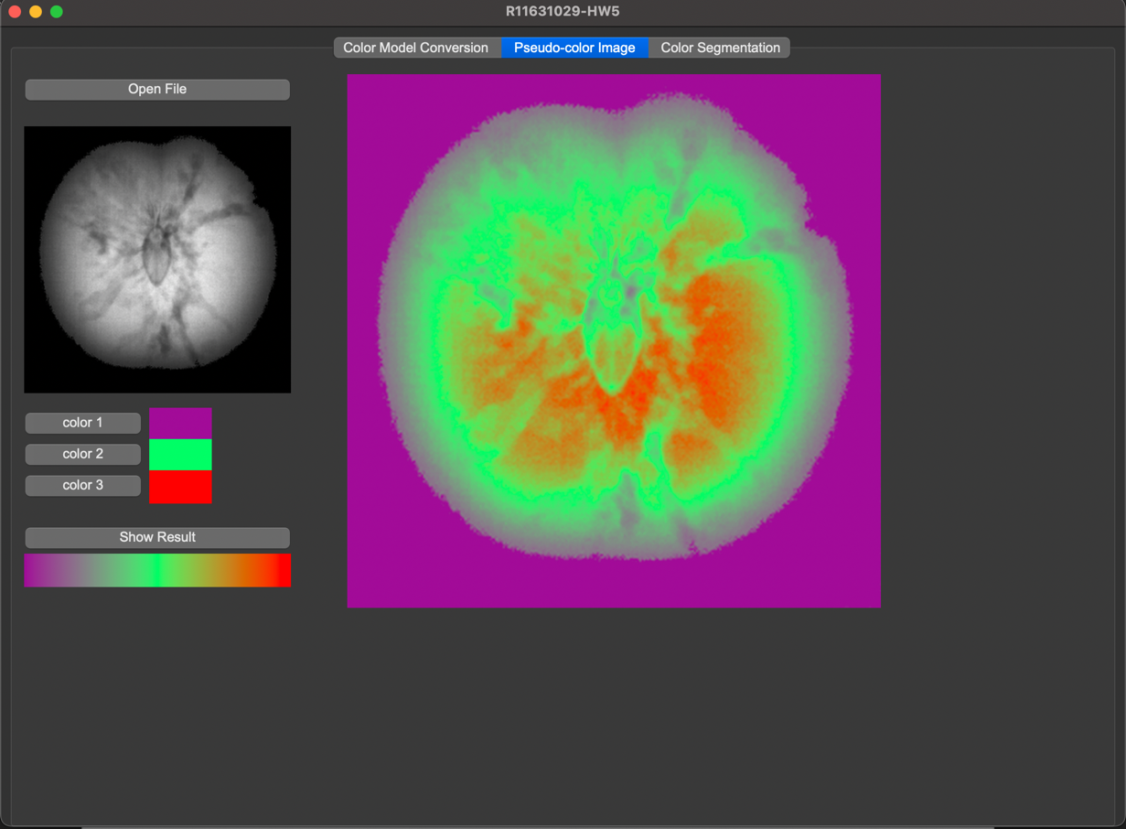

1. Color Segmentation

可見當K越多，及分割的區域越多，所以顯示上區塊也會變多。

Code:

def Kmeans(img, K):

# show_type = 1 : RGB

# show_type = 2 : HSI

# show_type = 3 : Lab

Z = img.reshape((-1,3)) # 將每一通道從2D變成1D

# convert to np.float32

Z = np.float32(Z)

# define criteria, number of clusters(K) and apply kmeans()

criteria = (cv2.TERM_CRITERIA_EPS + cv2.TERM_CRITERIA_MAX_ITER, 10, 1.0)

ret, label, center = cv2.kmeans(Z, K, None, criteria, 10, cv2.KMEANS_RANDOM_CENTERS)

# Now convert back into uint8, and make original image

center = np.uint8(center)

res = center[label.flatten()]

res_BGR = res.reshape((img.shape))

res_HSI = cv2.cvtColor(res_BGR, cv2.COLOR_BGR2HLS)

res_LAB = cv2.cvtColor(res_BGR, cv2.COLOR_BGR2LAB)

return res_BGR, res_HSI, res_LAB

